Entity Relationship Diagram (ERD)
7.1 Entities
Entity Name
  Attributes
  Description
User | - UserID (Primary Key)  - Name  - Email  - Role (Developer/Project Manager)  - Password | Represents users of the platform, including developers and project managers.
Project | - ProjectID (Primary Key)  - ProjectName  - Description  - CreatedDate  - Status | Contains details about software projects managed within the platform.
Task | - TaskID (Primary Key)  - TaskName  - AssignedTo (Foreign Key: UserID)  - DueDate  - Status | Represents tasks created for projects, assigned to users with specific deadlines.
CodeSuggestion | - SuggestionID (Primary Key)  - ProjectID (Foreign Key)  - Snippet  - Context  - CreatedBy | Stores AI-generated code suggestions and their relevant context within the project.
DebugReport | - DebugID (Primary Key)  - TaskID (Foreign Key)  - ErrorDescription  - ResolutionSteps  - Status | Maintains details of debugging sessions, including identified errors and proposed solutions.
LearningResource | - ResourceID (Primary Key)  - Title  - Type (Tutorial/Guide)  - Content  - AssociatedTopic | Contains educational resources tailored for developers and project managers.
Sprint | - SprintID (Primary Key)  - SprintName  - StartDate  - EndDate  - ProjectID (Foreign Key) | Represents sprints in the project lifecycle with start and end dates.
CollaborationSession | - SessionID (Primary Key)  - ProjectID (Foreign Key)  - Participants  - StartTime  - EndTime | Tracks live coding collaboration sessions and their participants.
VersionControl | - CommitID (Primary Key)  - ProjectID (Foreign Key)  - FileChanges  - CommitMessage  - CommitDate | Stores information related to version control, including changes and commit messages.
AIEngineLog | - LogID (Primary Key)  - TaskID (Foreign Key)  - Timestamp  - ActionPerformed  - Result | Logs activities and results performed by the AI engine during coding and debugging sessions.

7.2 Entity Relationship Diagram (ERD)
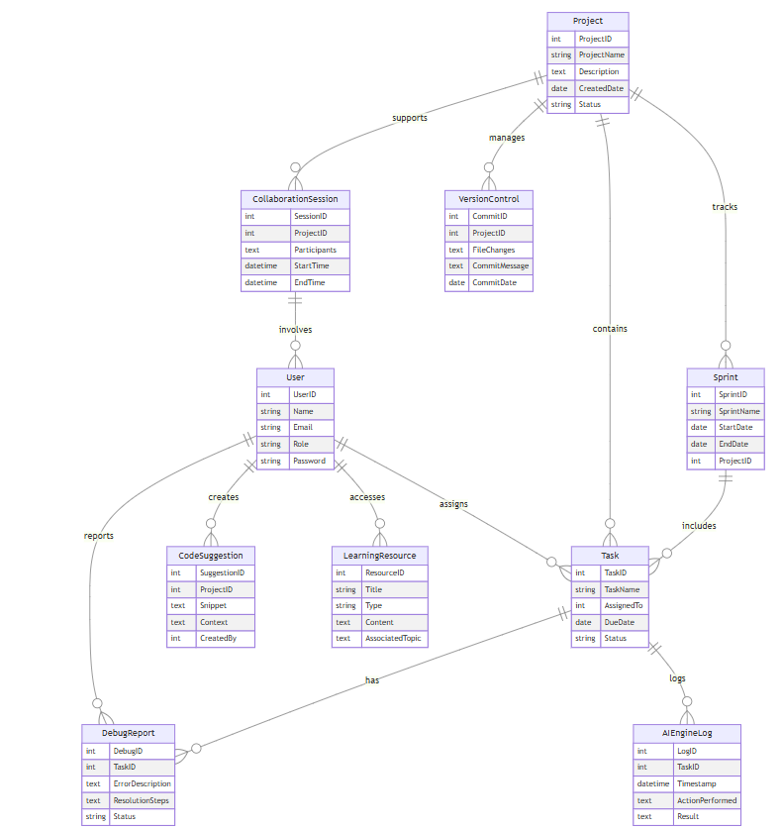

7.2.1 Entity Relationship Diagram

